Problem No: 2302056_101

Problem Name: There are three given ranges. Write a C program that reads a floating-point number and finds the range where it belongs from four given ranges.

Input:

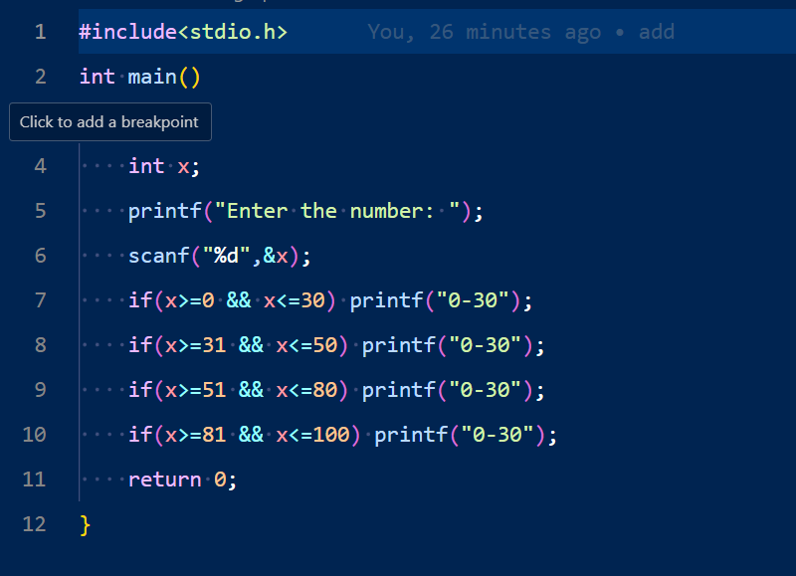

Output:



Problem No: 2302056_103

Problem Name: In science, a multiple is the product of any quantity and an integer. In other words, for the quantities a and b, we say that b is a multiple of a if b = na for some integer n, which is called the multiplier. If a is not zero, this is equivalent to saying that b/a is an integer.

Input:

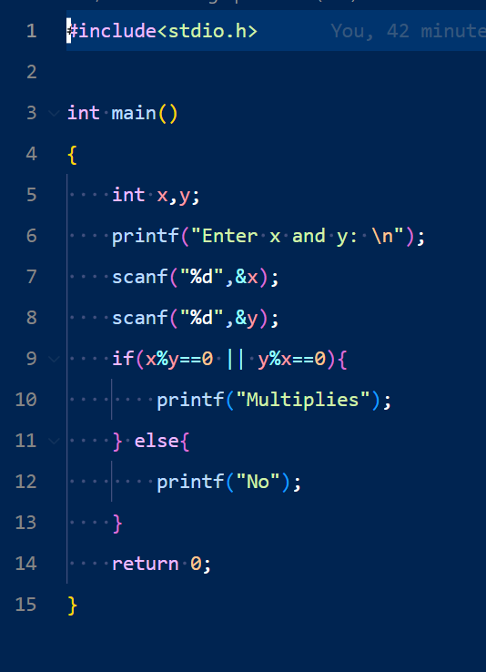

Output:

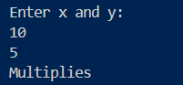

Problem No: 2302056_105

Problem Name: Write a C program that accepts seven floating point numbers and counts the number of positive and negative numbers. Print the average of all positive and negative values with two digits after the decimal number.

Input:

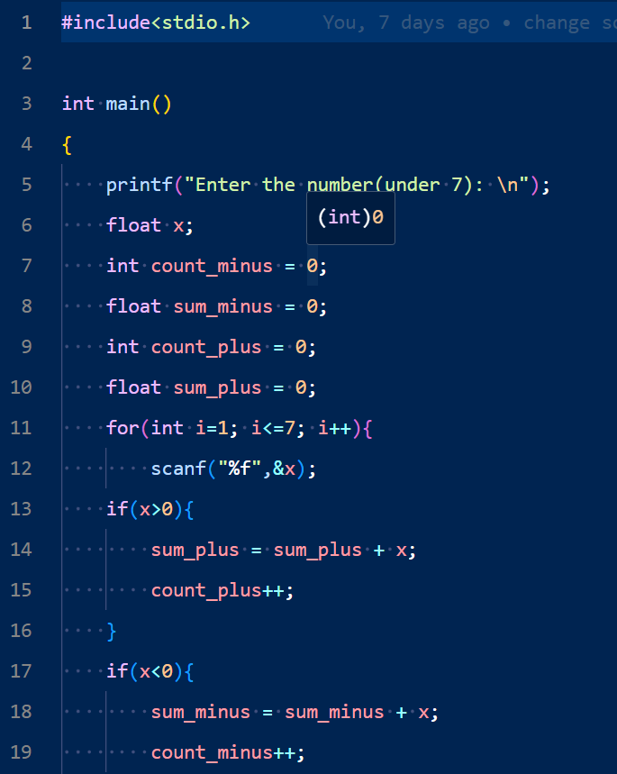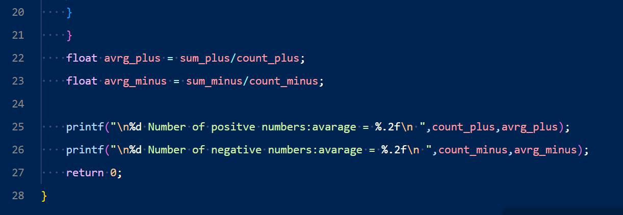

Output:

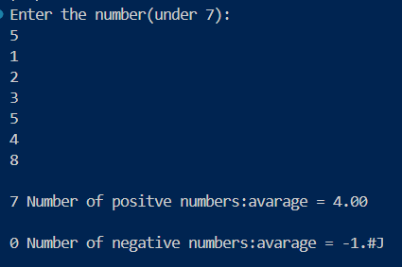

Problem No: 2302056_06

Problem Name: Write a C program that accepts 7 integer values and counts the even, odd, positive and negative values.

Input:

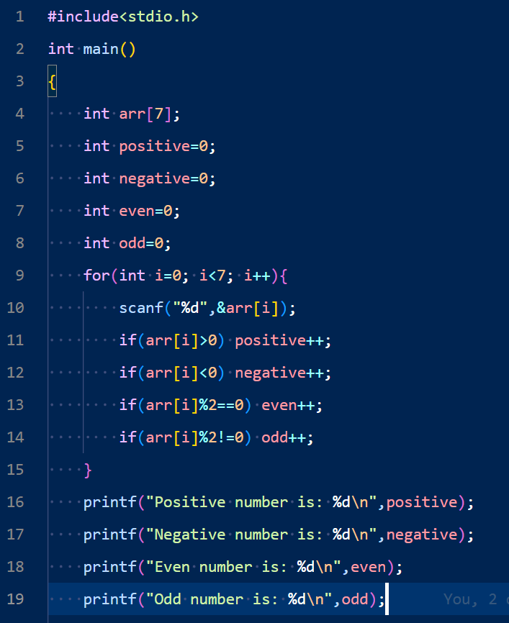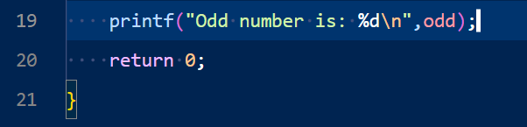

Output:

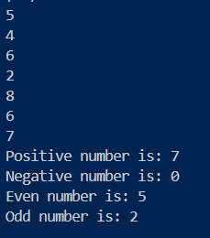

Problem No: 2302056_107

Problem Name: Write a C program that prints ten consecutive odd and even numbers after accepting an integer.

Input:

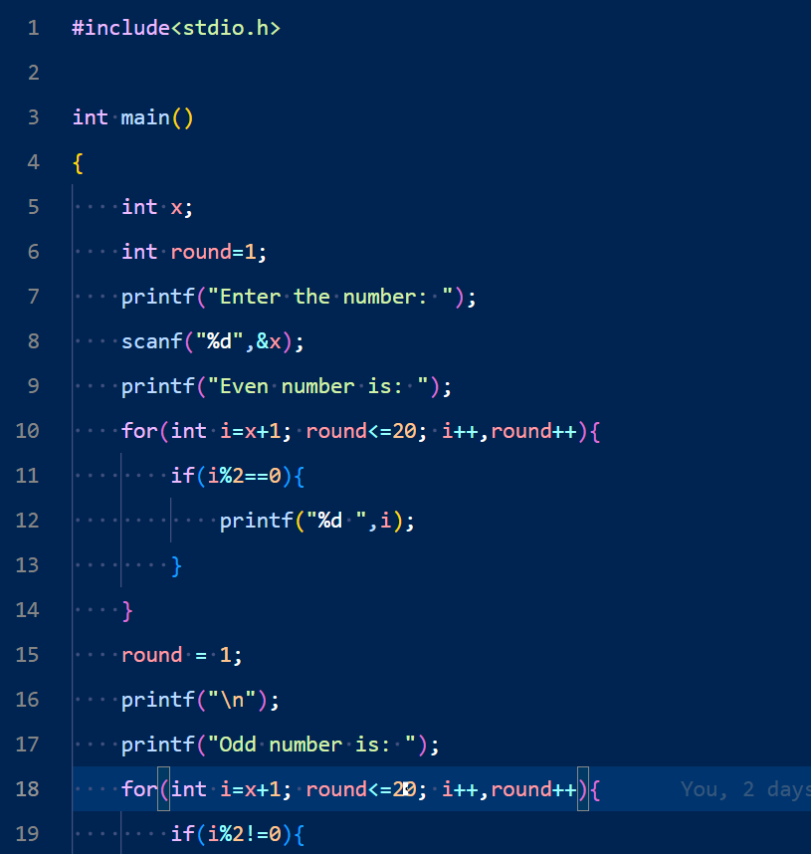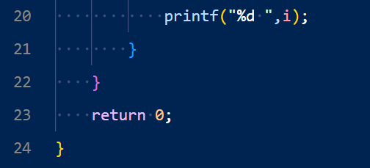

Output:

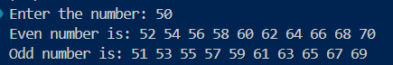

Problem No: 2302056_108

Problem Name: Write a C program that reads two integer values and calculates the sum of all odd numbers between them.

Input:

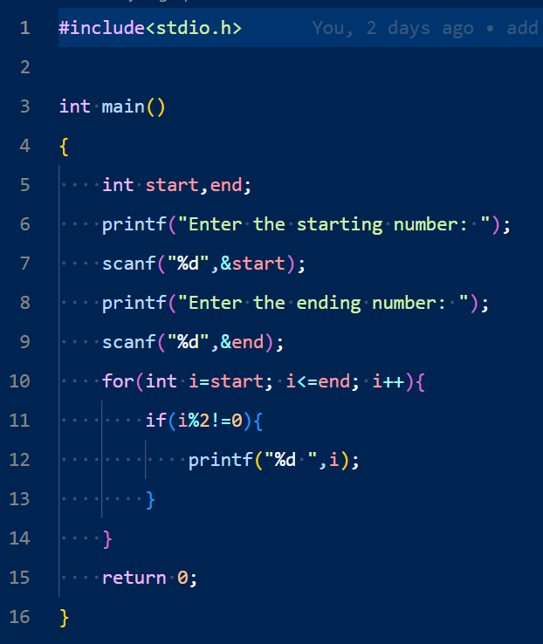

Output:

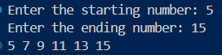

Problem No: 2302056_109

Problem Name: Write a C program to find and print the square of each even and odd value between 1 and a given number (4 < n < 101).

Input:

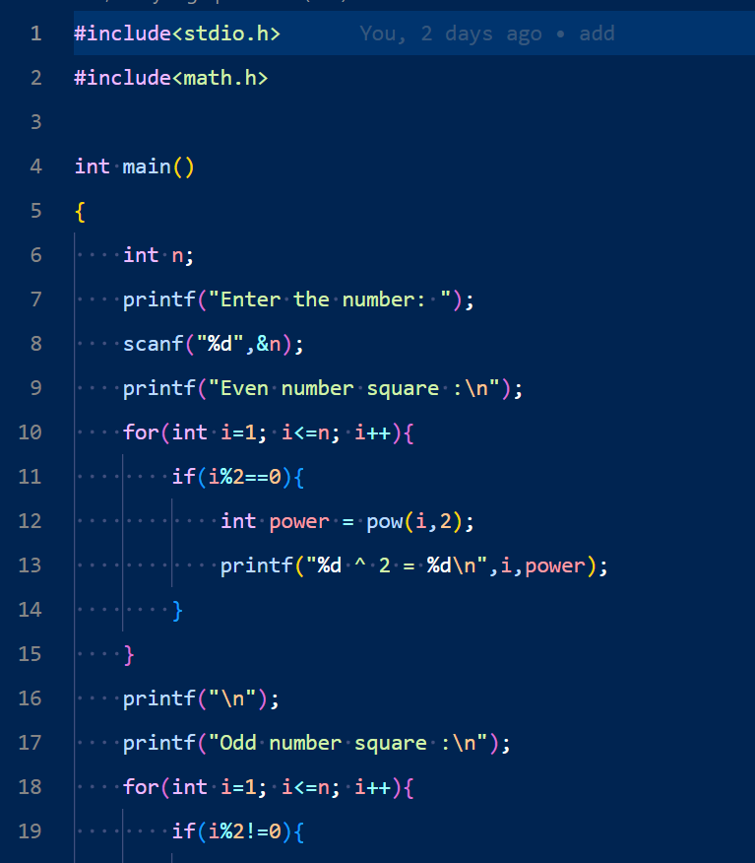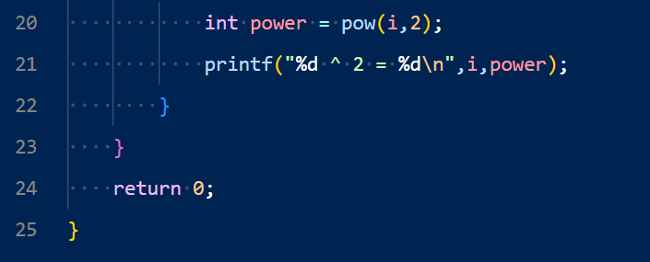

Output:

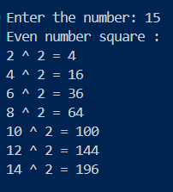

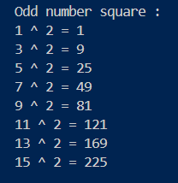

Problem No: 2302056_110

Prblem Name: 110. Classify a number as positive/negative and odd/even, or print "Zero"

Input:

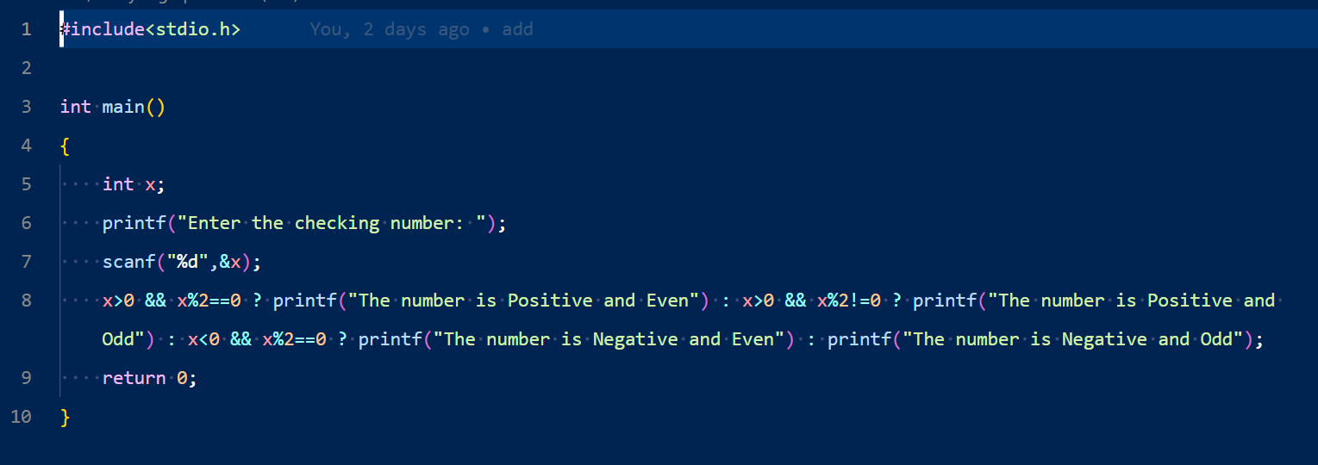

Output:



Problem No: 2302056_111

Problem Name: Write a C program that accepts an integer from the user and divides all numbers between 1 and 100. Print those numbers where the remainder value is 3.

Input:

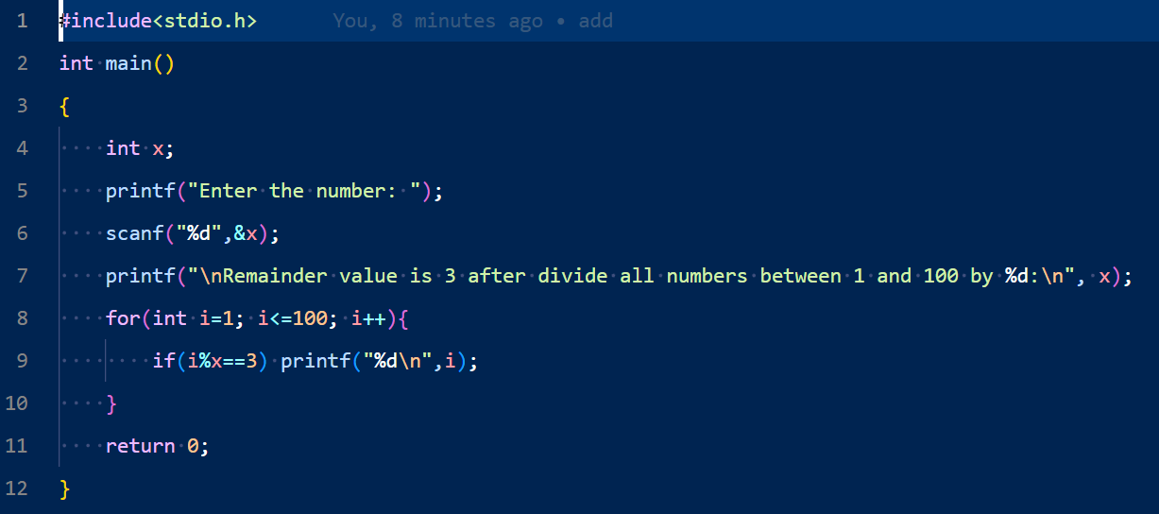

Output: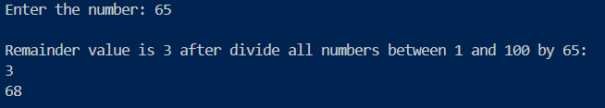

Problem No: 2302056_112

Problem Name: Write a C program that reads seven integer values from the user and finds the highest value and its position.

Input :

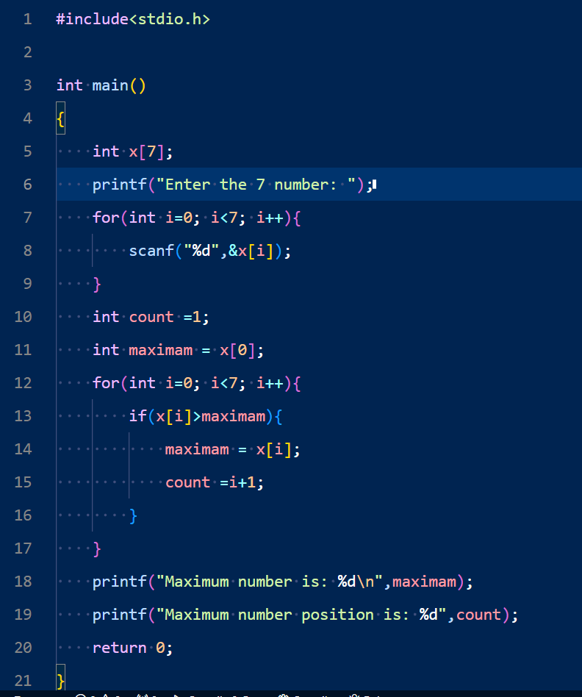

Output:

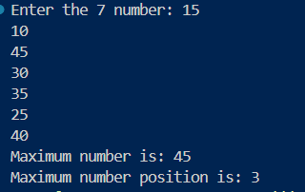

Problem No: 2302056_113

Problem Name: Write a C program to create and print the sequence of the following example.

Input:

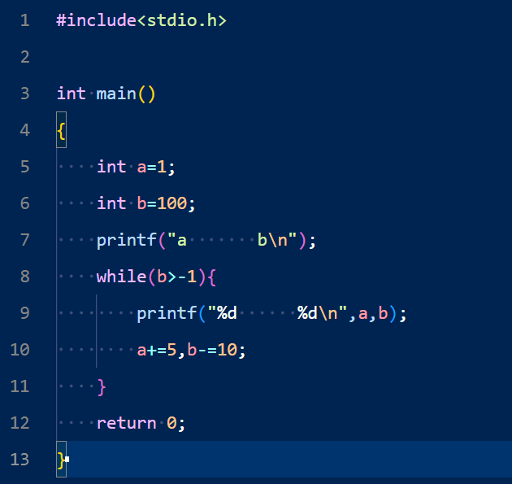

Output:

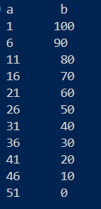

Problem No: 2302056_114

Problem Name: Write a C program that accepts two integer values and calculates the sum of all even values between them.

Input:

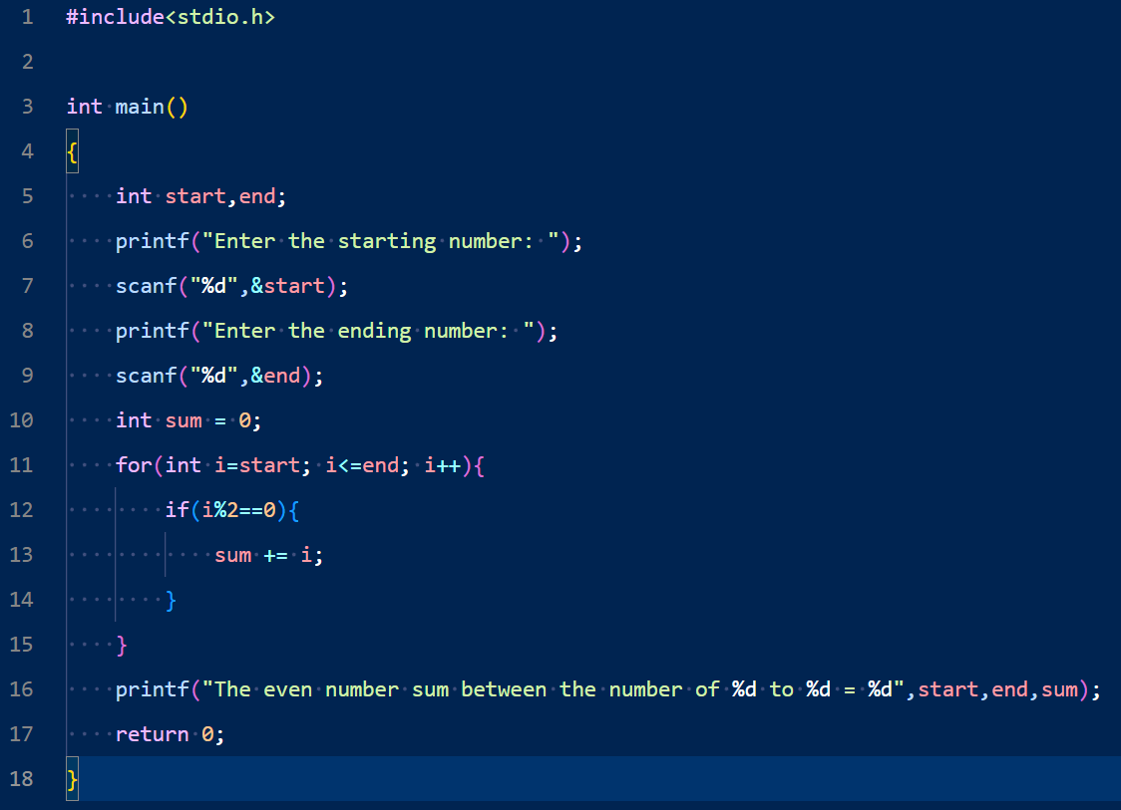

Output:

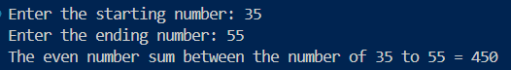

Problem No: 2302056_115

Prbolem Name: Write a C program that accepts a pair of numbers from the user and prints the sequence from the lowest to the highest number. Also, print the average value of the sequence.

Input:

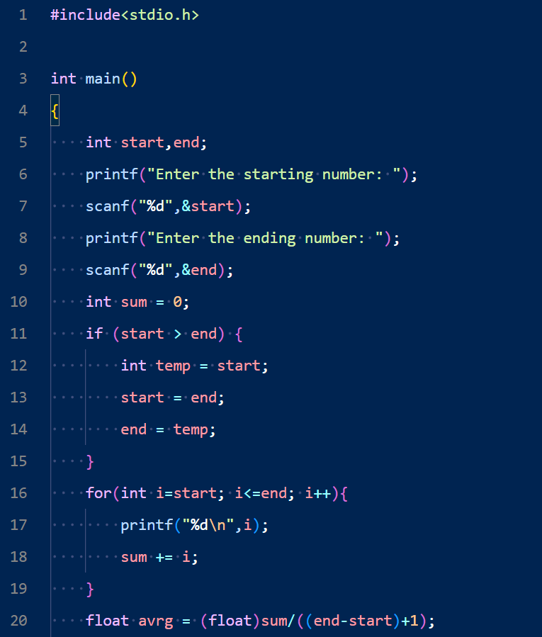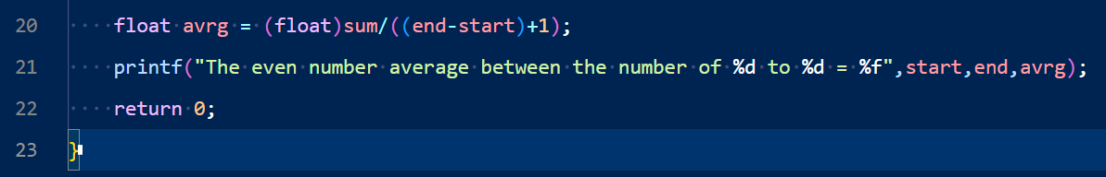

Output:

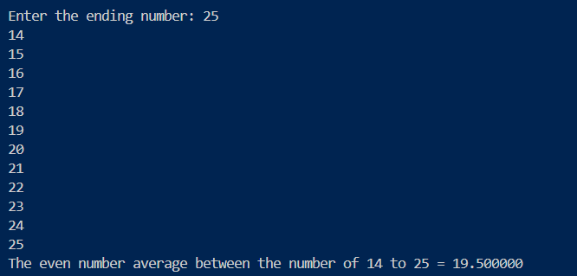

Problem No: 2302056_116

Problem Name: Write a C program that accepts a pair of numbers from the user and prints "Ascending order" if the two numbers are in ascending order, otherwise prints, "Descending order".

Input:

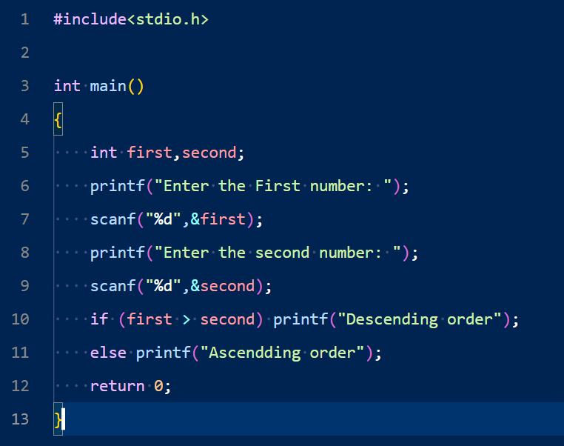

Output:

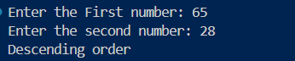

Problem No: 2302056_117

Problem Name: Write a C program that reads two integers and divides the first number by second, print the result of this division with two digits after the decimal point and prints “Division not possible..!” if the division is not possible.

Input:

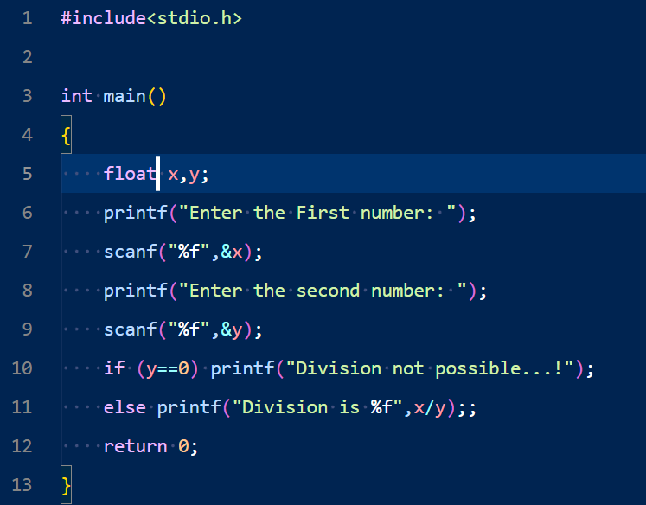

Output:

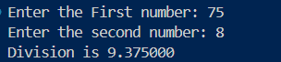

Problem No: 2302056_118

Problem Name: Write a C program that reads five subject marks (0-100) of a student and calculates the average of these marks.

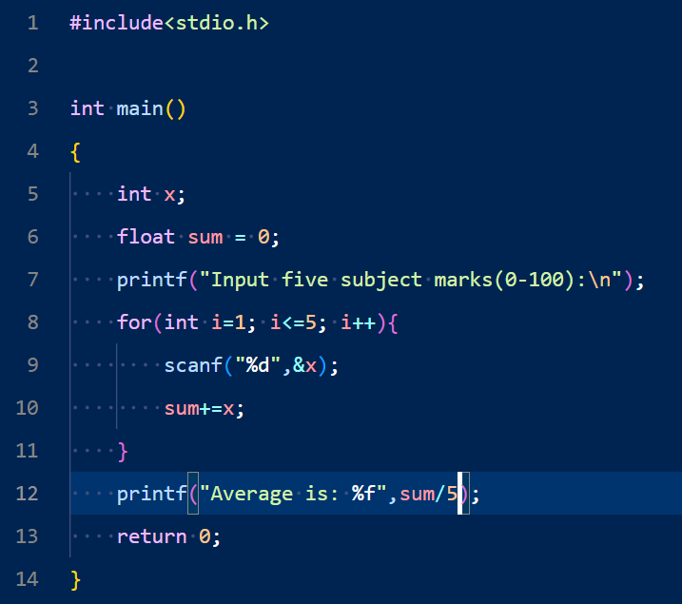

Output:

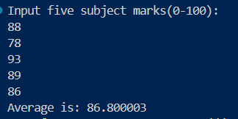

Problem No: 2302056_119

Problem Name: Write a C program to calculate the sum of all numbers between two given numbers (inclusive) not divisible by 7.

Input:

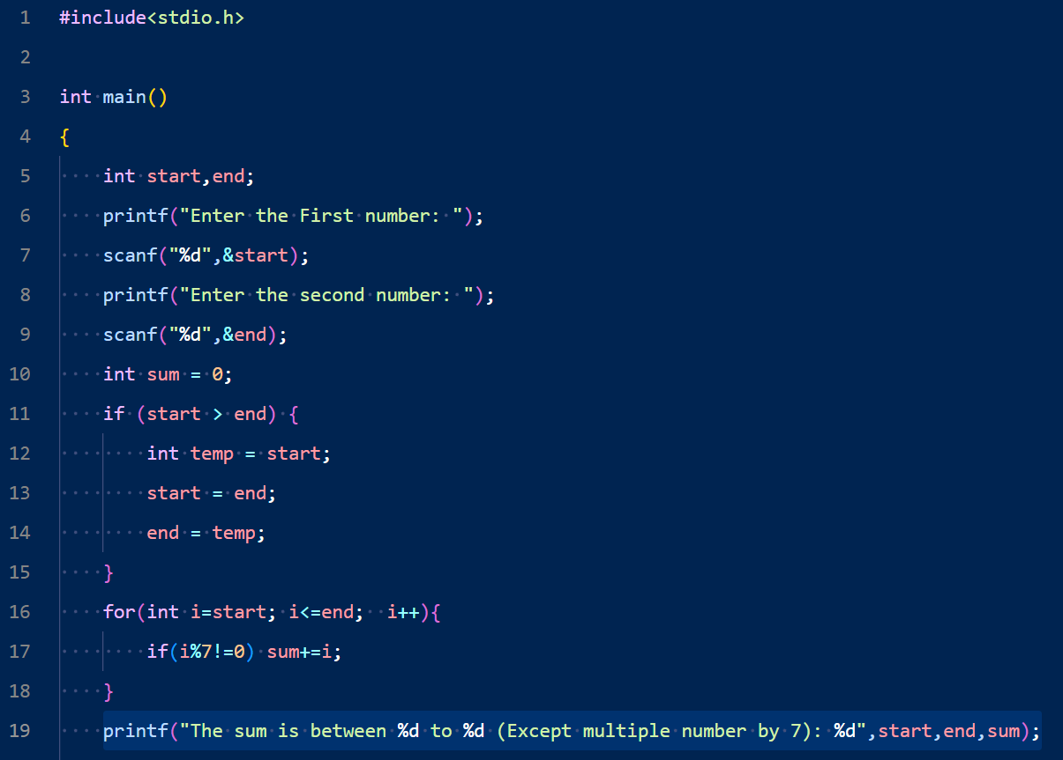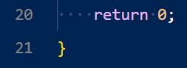

Output: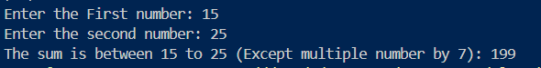

Problem No: 2302056_120

Problem Name: Write a C program to print a sequence from 1 to a given (integer) number, inserting a comma between these numbers. There will be no comma after the last character.

Input:

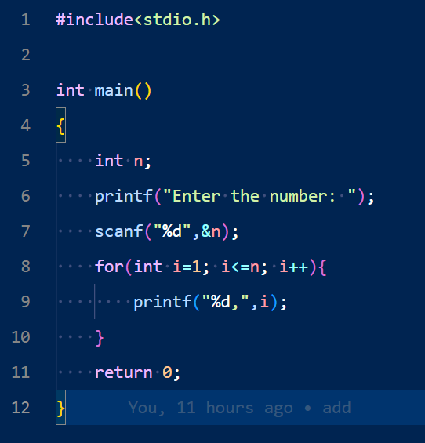

Output:



Problem No: 2302056_121

Problem Name: Write a C program that reads an integer and finds all the divisors of the said integer.

Input:

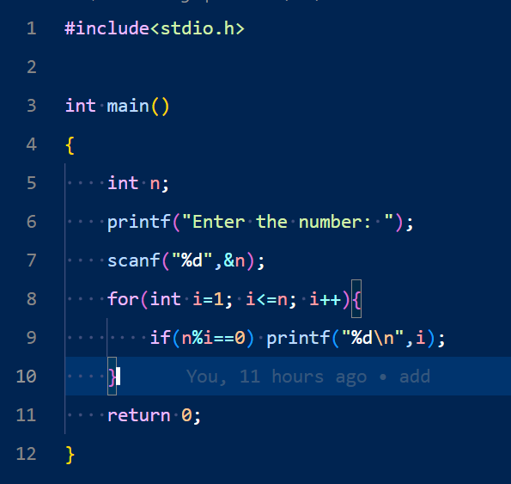

Output:

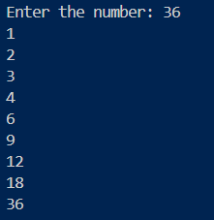

Problem No: 2302056_122

Problem Name: Write a C program that reads two integers m, n and computes the sum of n even numbers starting from m.

Input:

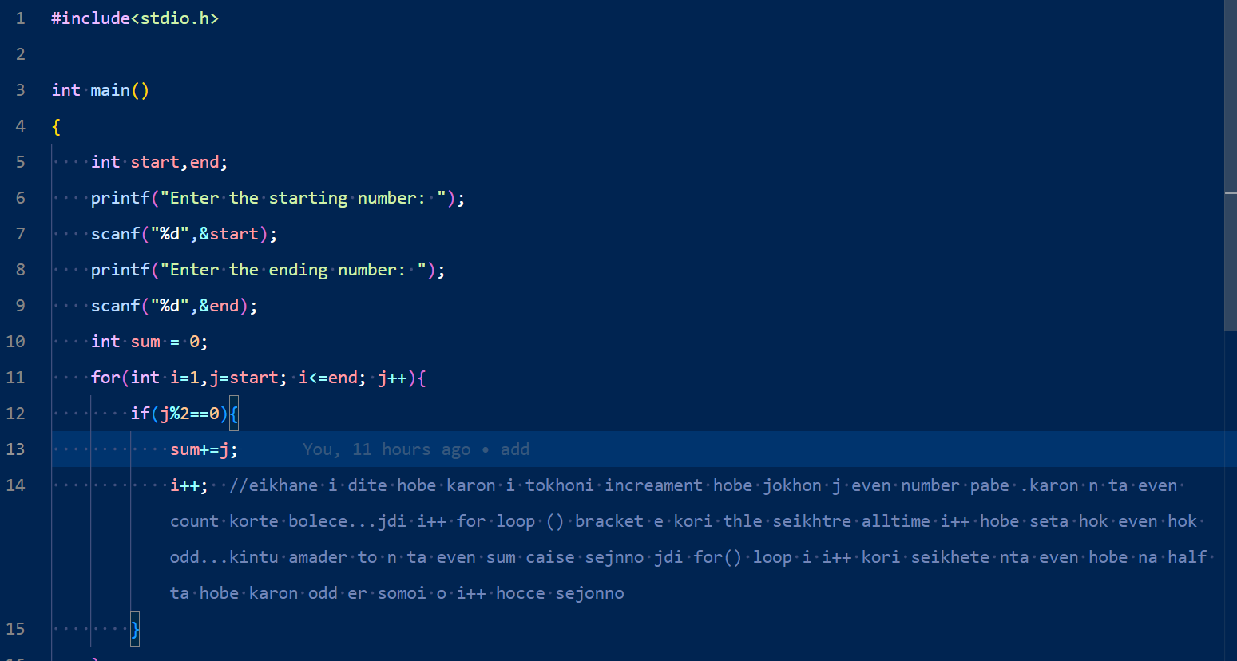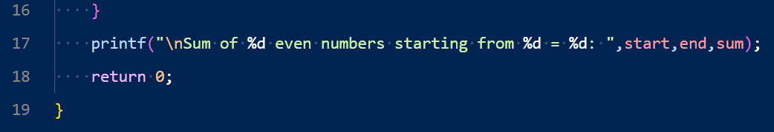

Output:

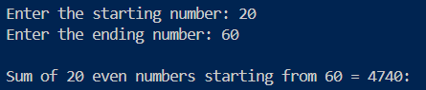

Problem No: 2302056_123

Problem Name: Write a C program that reads two integers m, n and computes the sum of n odd numbers starting from m.

Input:

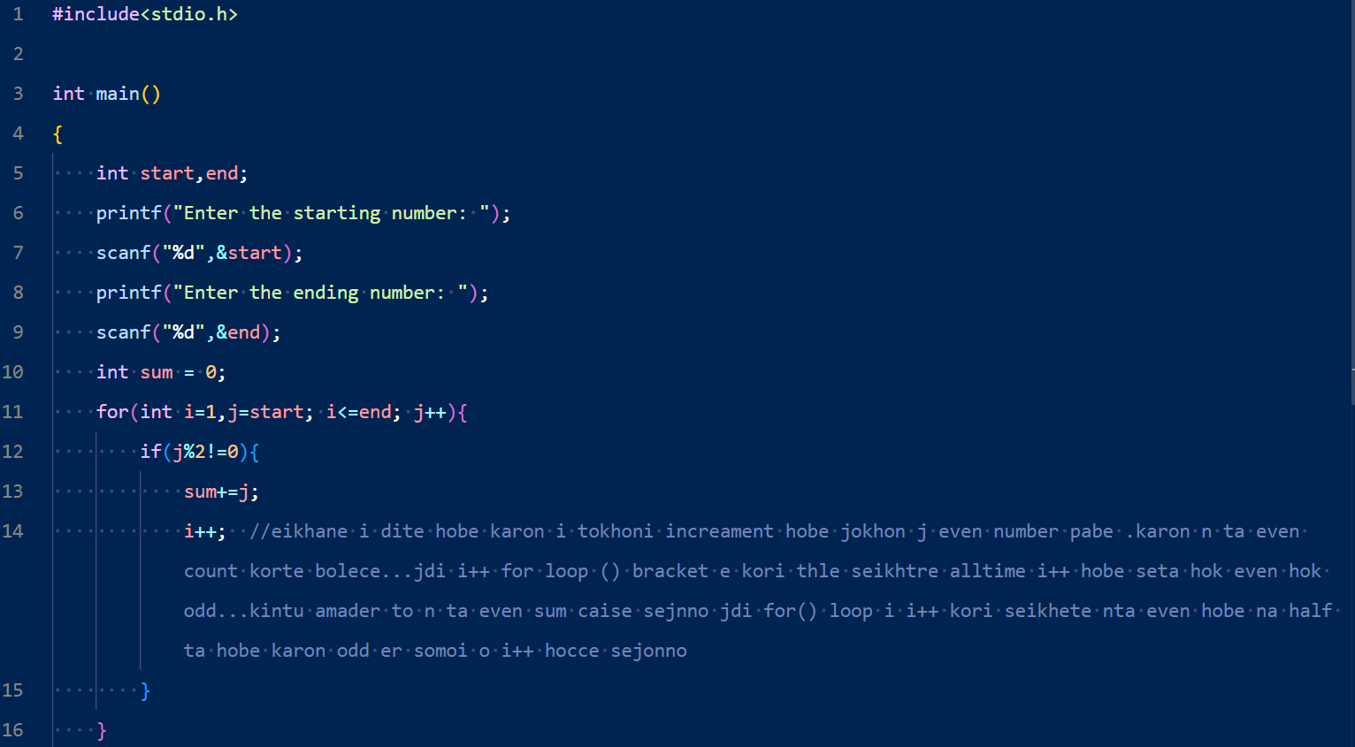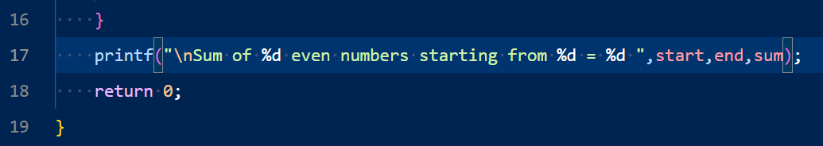

Output:

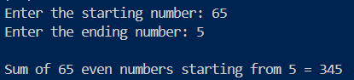

Problem No: 2302056_124

Problem Name: Write a C program that reads an array of integers (length 7), replaces every negative or null element with 1 and prints the array elements.

Input:

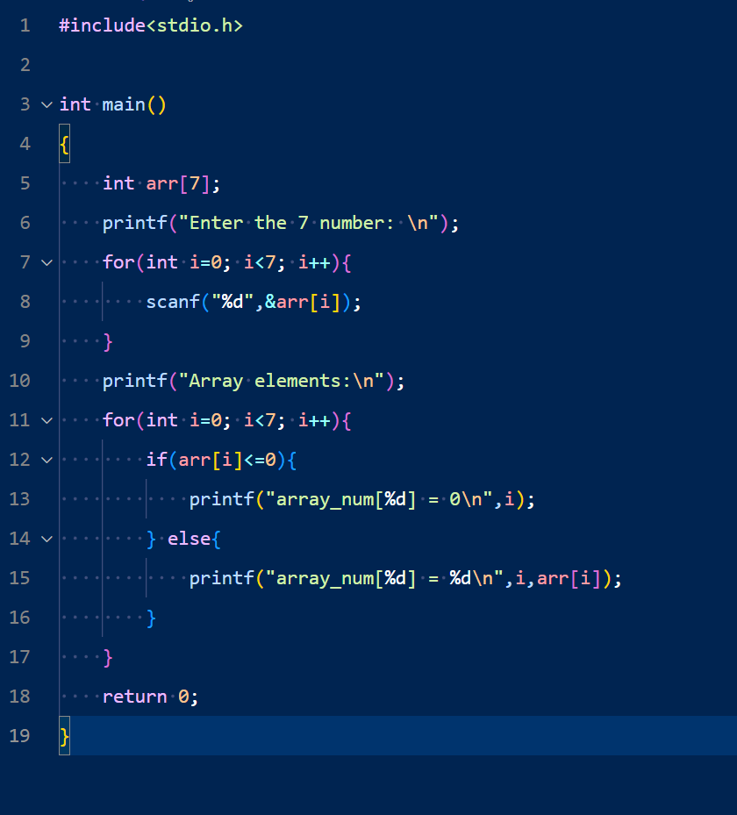Output:

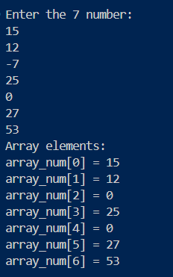

Problem No: 2302056_125

Problem Name: Write a C program that reads an array of integers (length 7), and replaces the first element of the array by a given number and replaces each subsequent position of the array by the double value of the previous.

Input:

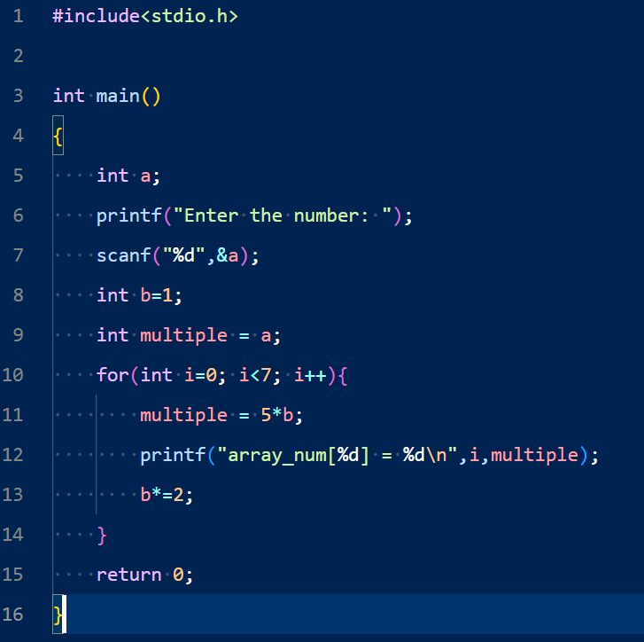

Output:

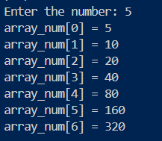

Problem No: 2302056_126

Problem Name: Write a C program that reads an array (length 7) and prints all array positions that store a value less than or equal to 0.

Input:

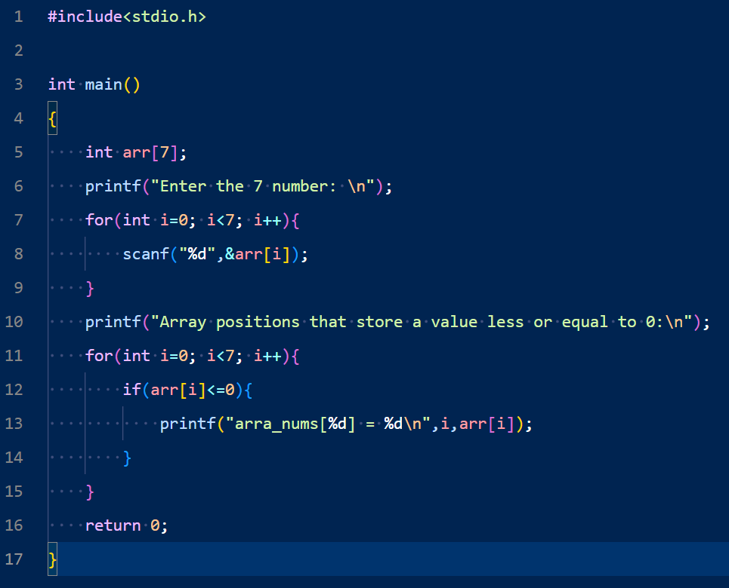

Output:

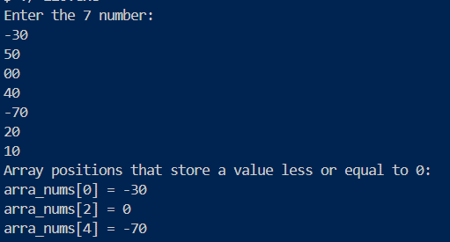

Problem No: 2302056_127

Problem No: Write a C program that reads an array of integers (length 8), replaces the 1st element with the 8th, the 2nd with the 7th and so on. Print the final array.

Input:

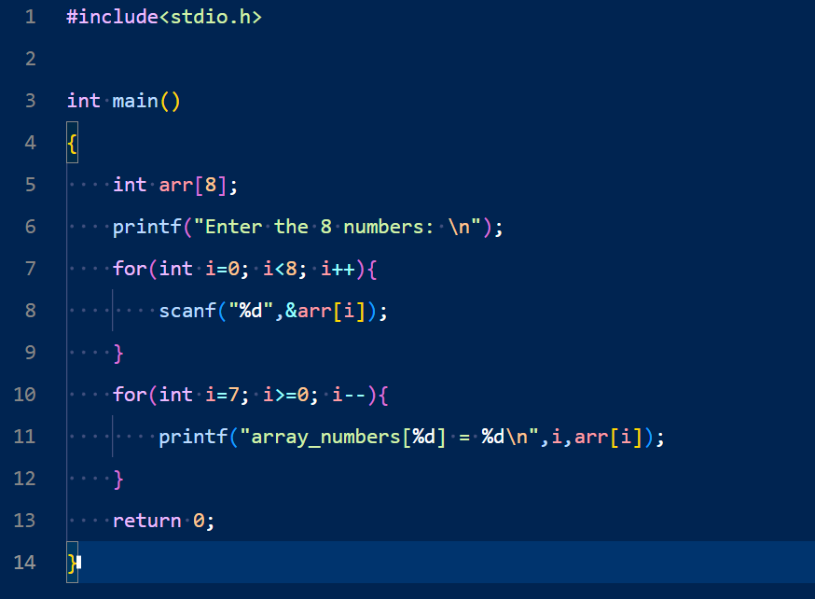

Output:

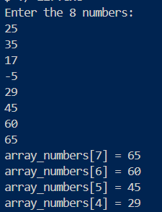

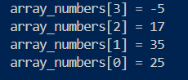

Problem No: 2302056_128